**WEEK – 04**

**Spring REST using Spring Boot 3**

**Superset ID: 6262264**

**Exercise 1:**

**Create a Spring Web Project using Maven**

**SOLUTION:**

***Project Overview :***

This project demonstrates creating a Spring Boot web application using Maven.  
It covers project setup, running the application, and understanding the structure.

***SpringLearnApplication.java:***

package com.cognizant.springlearn;

import org.slf4j.Logger;

import org.slf4j.LoggerFactory;

import org.springframework.boot.SpringApplication;

import org.springframework.boot.autoconfigure.SpringBootApplication;

@SpringBootApplication

public class SpringLearnApplication {

    private static final Logger LOGGER = LoggerFactory.getLogger(SpringLearnApplication.class);

    public static void main(String[] args) {

        LOGGER.info("START");

        SpringApplication.run(SpringLearnApplication.class, args);

        LOGGER.info("END");

    }

}

***Purpose:***

* @SpringBootApplication: Combines configuration, auto-configuration, and component scanning.
* LOGGER: Logs startup and shutdown.
* SpringApplication.run(): Starts the application.

***HelloController.java:***

@RestController

public class HelloController {

@GetMapping("/")

public String hello() {

return "Hello, Spring Boot!";

}

}

***Purpose:***

* @RestController: Marks this class as REST API.
* @GetMapping("/"): Maps GET requests to root URL.

***SpringLearnApplicationTests.java:***

@SpringBootTest

class SpringLearnApplicationTests {

@Test

void contextLoads() {

}

}

***Purpose:***

* Verifies the Spring context loads without errors.

**OUTPUT:** 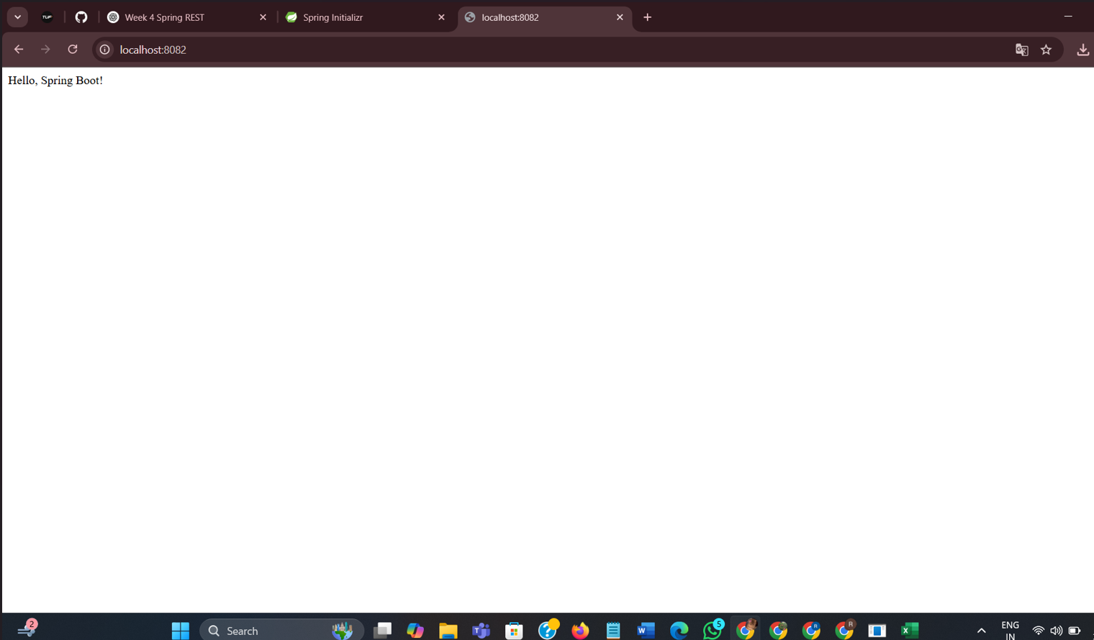

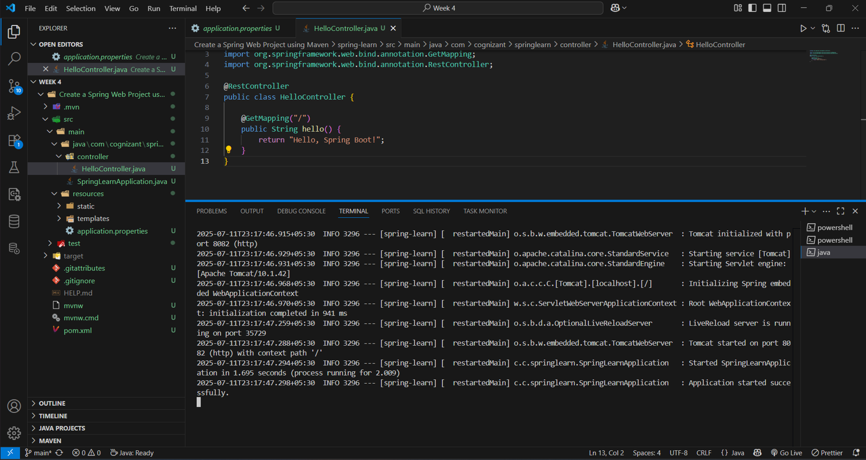

***Explanation:***

* The code defines a Spring Boot application where SpringLearnApplication acts as the main entry point using @SpringBootApplication to enable auto-configuration and component scanning.
* When executed, it logs "START" and "END" to confirm initialization and runs an embedded Tomcat server that listens for HTTP requests.
* The HelloController class, marked with @RestController, maps a GET request to the root URL / and returns the response "Hello, Spring Boot!".
* Additionally, the SpringLearnApplicationTests class verifies that the Spring application context loads successfully, ensuring the project setup and configurations are correct.